**6.1. Class task and assignment**

Pre-recorded lecture

<https://wisconsin-edu.zoom.us/rec/play/jYbmx7N8Bzx9ECdAdErxB67Nqas1mvZyJXLdBMF1SovnW2Kw--nF_zo-mgcOF9M3c-Wjb3oYhaBLvR9Z.1wVR5UFzLWJ-4xWG?continueMode=true&_x_zm_rtaid=noJZuYdOScmYcXJxfXrprA.1653561952102.455832b29eac958460fdce1a739c099a&_x_zm_rhtaid=330>

Today’s assignment is the final step of your final project. It is very important and requires everyone to participate in the recording. Please pay attention to the deadline—it will be Sunday night. That means you will have several days to complete the recording.

Please complete today’s writing assignment with your group members for the Final Project.请所有同学按照期末项目小组的分组，完成下面内容.

(* Below is the grouping information for those who had class conflict this semester这是课程有冲突的同学的分组)

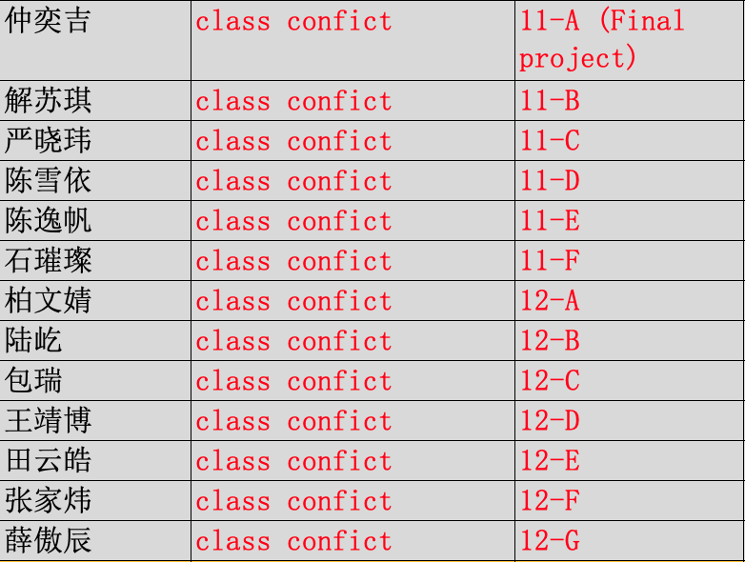

|  |  |  |  |  |
| --- | --- | --- | --- | --- |
| Step 6: Record your poster presentation on video (Entire group- you may choose a team leader, but this is an important team work)   * Each member needs to present one part. * You need to present your poster in the video * Your presentation needs to be at least 8 minutes long and no longer than 12 minutes. * You can submit your video in two ways: (1) Send me your video in a zip file of MP4 format. Or (2) upload your video to a website (such as bilibili or youtube), and send me a link to watch your video. * Tip: be sure to look at the grading rubric. * 录像：全组同学共同报告你们做的期末项目海报。录像里，可以分工报告，每人分享一部分，但是需要把各个部分放在同一个录像里。 * 有两种方式提交你的录像： （1）压缩mp4文档， (2) 上传你的视频到一个网站上（例如Bilibili和Youtube之类的),然后把链接发给我。 * 提示：认真看评分标准，可以帮助你们在准备过程中确保考虑到了每一点。   **Due Sunday night** | | | | |
| **Final project- oral presentation** | | | | |
| * The presentation includes clear main title and group #. * The presentation addresses all the components of this final project: context of IoT, identify a problem, suggest solutions, and civic duties. * The presentation has a clear beginning (introduction) and a clear conclusion. It is a complete presentation and the flow is logical. * The entire presentation is more than 8 minutes, and no more than 12 minutes long. * All group members have participated in the presentation and the transition between members is smooth. * All members demonstrate that they understand the entire project and each other’s portion. There are no repetitions or contradictions between members. * The presenters demonstrate a good control of eye contact, tone and voice, and body language. * The presenters speak fluent and clear English. It is clear that the presenters understand the content and have done some practice. * The presentation video is submitted on time and in a correct format. | | | | |
| **Excellent work** | **Good work—mostly meet the requirements** | **Average work—partially meet the requirements** | **Below average- missing multiple elements and/or not following instructions** | **No submission, or submitted a wrong document, or failed to follow any instructions** |
| 10 | 8-9 | 6-7 | 1-5 | 0 |

**Assignment for next class:**

No assignment for today. Just work on the video recording.